Time to Go DVD?!

I’d been predicting it for a while. Before long we’d see the first astronomy program go DVD. Well, that’s finally come true with Deepsky 2003. Not much of a prediction, really. Obviously, the DVD medium with its ability to hold gigabytes of data, rather than mere megabytes like the CD, is a natural for astro programs with their huge catalogs. So it was really no surprise to me when Steve Tuma, developer of Deepsky 2002, one of the best planning/logging programs out there, told me he was interested in making the forthcoming “2003” version of his popular program available on DVD as an option. Sounded good to me! After quite a bit of beta testing, the first DVD-based astronomy program that I’m aware of was in its final release form and on my doorstep.

What did I think? The basic program has evolved and improved a great deal over the last 5 – 6 years, and now runs very well, very smoothly indeed. Like any complicated piece of software, there may still be a few bugs lurking, but not many. Steve has rigorously beta-tested this program prior to each new release, and has been quite scrupulous about listening to his users’ comments and taking their bug reports (via a Yahoo mailing list).

If you’re interested in learning the basics of this program, let me refer you to my reviews of its earlier versions in past Skywatch issues (there’s a link to these on the Deepsky 2000 web page). But to describe a very full-featured program in a few words, Deepsky 2003 provides an observing system for deep sky fans. It will allow you to search through databases of hundreds of thousands of objects (try 708,000) for targets to add to your lists, provide data on each object, print charts that will allow you to find your objects, guide a goto telescope to them, and log your observations when you’re done.

The program media and installation? When you buy the DVD edition, what appears in your mailbox is two disks, one, a CD, containing the program and database files, and one a DVD, which at this point only holds images. Installation is foolproof this time through, with everything going smoothly and your computer not even asking for a “restart” when you’re done.

But the subject here is the “new.” The following are the highlights of what Steve has managed to stuff into DS2003.

-DVD edition includes images for 400,000 objects. When I’m planning an observing session, I like to be able to see photographs of the objects I’m after. It just helps a lot, letting me determine whether a galaxy, nebula, or cluster is worthy of inclusion in my list, aiding me in locating a DSO, and helping me pick-out details once the object is found. Sure, you can download pictures from the Digitized Sky Survey. But that’s time consuming, and what if you’re in the field without an Internet connection? That’s the beauty of the DVD. It took a while for it to sink-in, but it finally dawned on me that this DVD was all I’d probably ever need. I mean, 400,000 objects means you’ve not only got images of the entire NGC at your fingertips, it means that just about anything on your list or on your chart, even eensy-weensy PGC galaxies has an associated picture!

How well does this huge DVD image database work? Incredibly well. I was a little concerned about retrieval times, but even my bargain basement DVD ROM drive brings ‘em back in just seconds. Just click on the “image” field in a DSO’s listing on your object spreadsheet and there you go. Alternatively, choose “Object Details” from the right-click menu, and you’ll find the same image under an “image” tab in the Details window. Image quality? Very good. The most important objects are represented with large-scale images as in Plate 1. But even tiny PGCs are represented with decent-sized, legible photos as in Plate 2. The Image Processing window that displays the photos includes plenty of tools to adjust brightness and contrast, produce negative images, etc. Don’t like the way a retrieved image looks, though? Too small? Too grainy? While most are very good, you may occasionally be able to retrieve a better-looking, more “legible” picture yourself from the Digitized Sky Survey. If you’ve got an Internet connection, all it takes is a click of a button in the Image Browser tab from the main spreadsheet display to download a “fresh” image.

-Pocket Deepsky is included on the program CD. I’m a Palm person, myself, so I haven’t been able to test the Deepsky Pocket PC version that’s included on the CD, but I’ve been told by the PPC gang that it’s very nice, allowing you to download objects from the desktop program and into your handheld. This was formerly an extra-cost option, but it’s now included on the program CD.

-Several new catalogs have been added, including, most notably, the SAC Double Star Catalog.

-The Object Details window is much improved, and now includes separate tabs for displaying an object’s image and a chart, rather than trying to cram everything into one window as on early versions.

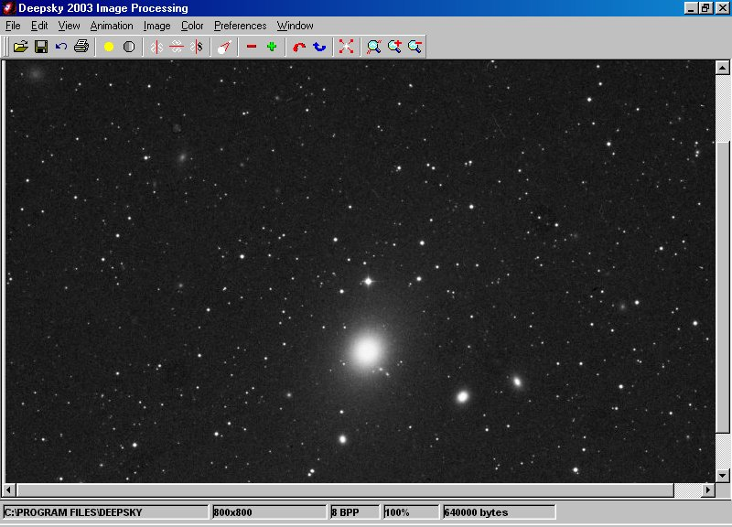
-The program still interfaces with Patrick Chevalley’s Cartes du Ciel, but it now also features integration with Patrick’s new program, Virtual Moon Atlas. Don’t ask me why a Lunar observer would be roaming around in DS2003, but if you are and get the yen to look at detailed Lunar features, you can.

This is just a very small sampling of what’s new in Deepsky 2003, and doesn’t even begin to address the improvements Steve has made, both to the program itself, as in fixing problems, and in improving the databases.

Features, new and improved, are good. But am I basically happy with this program as a whole? Yes, I am. No, it’s not perfect—which astronomy program is? But my criticisms are getting fewer and fewer all the time. At this point, the weakest link is probably still the Star Charting module. This part of the program, done by Dean Williams, is mostly unchanged since the program’s earliest days, and is a little awkward and certainly less user friendly and easy to use than its moniker, “Interactive Charts” would suggest. I’d like to see a major rework of this part of the program, including, most importantly, the ability to overlay those 400,000 pictures onto your charts. Of course, the program’s tight integration with Cartes du Ciel means you don’t have to use the built in charts. But it would be nice if they were just a little better. My impression is that the bugs and rough edges that remain—and there are a few --are in the charting area.

Actually, the main question facing many folks when it comes to deciding whether to try DS 2003 DVD Edition will be: “Do I buy a DVD drive just to use this astro program?” Many of us are using older computers, especially in observatory settings, for our astronomy computing needs, and if a machine is more than two years old, it probably didn’t come with a DVD drive. You could get the 2003 program, on CD, as it’s still available in that format. You even get some images, and can order additional CDs with more. That’s OK, but it is nothing like the convenience of having the full library of 400,000 pix online all the time! If you don’t already have a DVD ROM for your PC, my advice is get one. This is likely just the first in a long line of astro-programs that will demand a DVD ROM reader. If you’re using a desktop, this is really a no-brainer, as you can buy a DVD drive for your desktop for 30 dollars or less on Ebay all day long. Believe me, when you start browsing the depths of space, seeing wonder after wonder flash onto your monitor screen as it’s pulled off your DVD, you’ll thank your old Uncle Rod for insisting you go DVD. Or more properly, you’ll thank Steve Tuma for delivering such a nice program at such a reasonable price.

